What is Dependency Injection?
Dependency Injection (DI) is a core, built-in feature of .NET Core and ASP.NET Core that promotes loosely coupled, testable, and maintainable code. The framework provides a built-in Inversion of Control (IoC) container that manages service creation and lifetimes.
Core Concepts
- Loose Coupling: Classes depend on abstractions (interfaces) rather than concrete implementations, making it easy to swap components without modifying dependent code.
- Testability: You can easily inject mock or fake implementations during unit testing.
- Centralized Configuration: All services are registered in a single location, typically the Program.cs file.
Interface code
public interface IUserService
{
Guid GetRequestId();
}
Service code
public class UserService : IUserService
{
private readonly Guid _requestId;

public UserService()
{
_requestId = Guid.NewGuid();
}

public Guid GetRequestId()
{
return _requestId;
}
}
Controller code
public class TestController : ControllerBase
{
private readonly IUserService _userService1;
private readonly IUserService _userService2;

public TestController(IUserService userService1, IUserService userService2)
{
_userService1 = userService1;
_userService2 = userService2;
}

[HttpGet]
public IActionResult Get()
{
return Ok(new
{
Service1 = _userService1.GetRequestId(),
Service2 = _userService2.GetRequestId()
});
}
}

Program.cs file code
builder.Services.AddScoped<IUserService, UserService>();

Service Lifetimes (Most Important Topic)
.NET Core provides three lifetimes:
Lifetime | Created | Destroyed | Typical Use
Transient | Every time requested | Immediately after use | Lightweight, stateless services
Scoped | Once per HTTP request | End of request | Business logic, DbContext
Singleton | Once per application | App shutdown | Caching, configuration
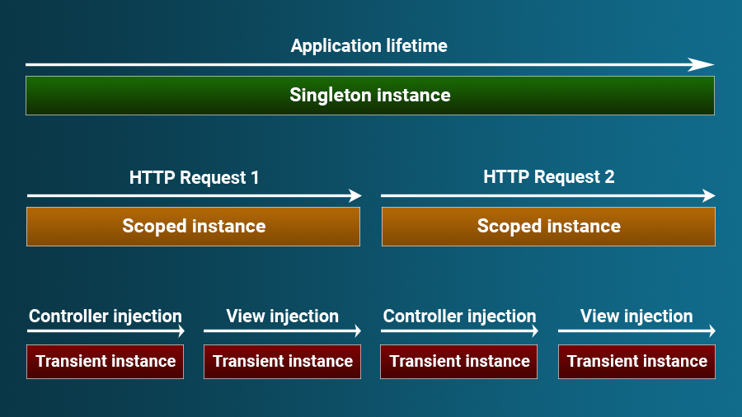

Example
builder.Services.AddScoped<IOrderService, OrderService>();

